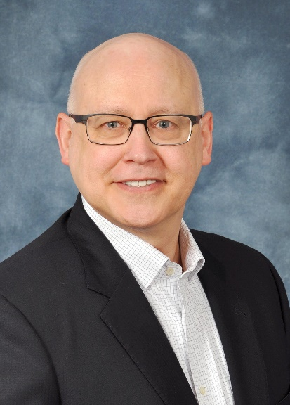

**TERRY BURKE**

Senior Healthcare Leader

and Strategic Advisor

Savvy P&L Owner

Turnaround Specialist

Experienced C-suite and board presenter

*Signature Strengths*

Strategic, Achiever, Relator, Activator,

Innovation Practitioner, Trailblazer,

Culture Builder, Servant Leader

**TERRY BURKE** inspires a shared vision and brings it to life through sound strategy development and an agile implementation roadmap. He intuitively sees the unique strengths and talents in others, enabling them to act as a coherent whole and achieve high impact results. Consistently grounded in financial information that levers the business, Terry uses storytelling to encourage the heart to build a culture of trust and inclusion. As an innovation practitioner and outspoken advocate for the customer, he is in relentless pursuit of better, faster, leaner. Terry is a respected and credible voice in decision making and rallying a business from now to next. As a servant leader, he earns a seat at the table wherever he serves.

After a decade at Blue Cross Blue Shield of Michigan (BCBSM), Terry is currently a strategic advisor to healthcare start-ups and collaterals. While at BCBSM, he was vice president and segment leader of the individual business segment, holding full profit and loss responsibility for the segment. During his leadership tenure, the individual business turned around from perennial losses to the segment’s first ever positive margin. Terry sustained year-over-year positive margin by successfully navigating through the market volatility, uncertainty and complexity of the Affordable Care Act headwinds.

Terry’s leadership career has consistently included P&L responsibility, and in each tenure, he has led a financial turnaround from losses to sustainable margin. He has held P&L leadership positions across diverse multi-billion-dollar entities, including publicly traded as well as nonprofit mutual, and as COO of a $75 million privately held entity. Also, as a board elected officer at Blue Cross Blue Shield of Virginia, he reengineered his business segment as the company converted from a nonprofit mutual to a for-profit, publicly traded stock company called Trigon.

Terry holds an MBA in marketing and entrepreneurship, and a BBA in finance and actuarial science, both degrees from the Lindner College of Business at the University of Cincinnati. His professional credentialing includes Certified Healthcare Financial Professional, Certified Healthcare Storyteller, Certified Customer Experience Professional and Chartered Leadership Fellow.

Terry currently serves on the board of Detroit Public Television and has held previous board positions with the Michigan chapter of Juvenile Diabetes Research Foundation, JDRF of southwestern Virginia and was appointed by the Virginia Department of Health Commissioner as a board member to the Southwest Virginia Regional Health Planning Agency.